Before You Start Designing

Starting to draw can be taxing if bad habits are developed and these lead to pains and aches in hand, arm, shoulder or neck. If these basic suggestions are followed you should enjoy your drawing experience and feel fresh and comfortable all day long without having to stop to release tension.

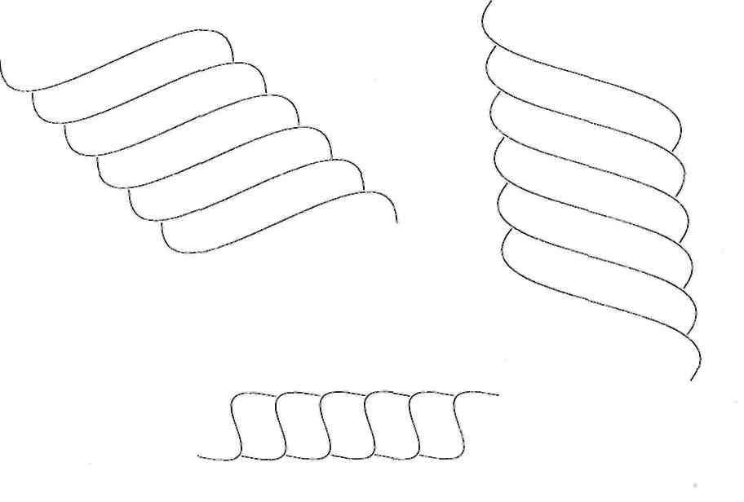Working with new and unusual equipment can be a challenge at the beginning but as soon as you get accustomed to these important tools and know when to use each one for which process it will become a joy. The more comfortable you are the better your designs will be, it quickly shows if a designer is relaxed as the designs flow smoothly and look great.

## Getting to know your pencils

ForeshorteningMost people have used an HB at some time or another and this will feel familiar, however few have tried the 2H lead which feels much harder and looks much lighter on your paper. We will complete a series of easy exercises which will require the same drawing using both pencils to fully understand the difference between the two and to become more familiar with the 2H lead.Notice the difference in colour, thickness and hardness!

## Understanding lines and shapes in jewellery

Almost any line or shape can be used in jewellery designs. We will explore straight parallel lines and soft curving lines with both types of leads. Squares, Circles, Ovals and Triangles are next, followed by Graduating Circles in ascending and descending order. The later are most useful as graduating diamonds which are commonly sketched as accent stones of a great many jewellery pieces.

More quick shapes follow such as Circles to Ovals typically displayed as diamonds on a curved surface rounding away from the eye (a prelude to Foreshortening). Last the soft and fluid ‘S’ shapes which denote a twisted shape of possibly chain links connected one to the other. By the time you have produced a couple of pages with these lines a shapes, you will be comfortable with both pencil leads and some even decide that they enjoy the 2H more than expected.

## Posture is important to not getting tired

As you do these simple exercises it is important that you are aware of you posture.

* Are you sitting uncomfortably?
* Are you gripping the pencils too tightly?
* Your back should be straight and upright, notice if you are slouching?
* Is your head uncomfortable or at a tilt?
* Your feet should be comfortably placed flat on the floor notice if they are wrapped around the chair legs?
* Are your shoulders raised un-naturally?

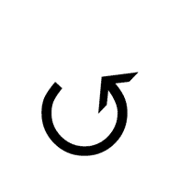If any of these questions can be answered by “Yes” then please try to correct your posture. If the table is too high or low, this can be adjusted. Maybe the chair is too high or low, this too can be changed but if you are uncomfortable and with a bad posture while you draw there will be no positive result as you will increasingly become more tired and develop pain and your designs will be forced instead of great. Posture is so important.



## Accuracy and personal style

As previously discussed accuracy is paramount in designing fine Jewellery and if you are not comfortable you will not be accurate. Comfort comes in many forms and one interesting example would be to notice while you do these simple exercises whether certain forms or shapes flow better in one direction over another. I.e. When you draw a circle, do you draw clockwise or anti-clockwise? When you draw a parallel line, do you draw from left to right? Or right to left?

Try and see which direction feels most comfortable for you and stick with it. If you know which direction works best then your designs will be faster, smoother and certainly more accurate. Forcing the hand to do something it is not comfortable to do will not get good results.

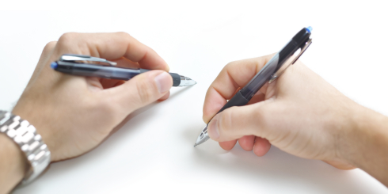

## Left handed or right handed?

No matter which hand is dominant you can be a great jewellery designer. At this stage comfort is the key. Later when we prepare our guidelines for drafting techniques there will be slight differences which will be explained but all surmountable and easy to understand.